ASSIGNMENT 17:

Use the excplict cursor to update the salary column as 25% of basic_pay as bonous and update this to get the netsalary.

AIM:

Use the excplict cursor to update the salary column as 25% of basic_pay as bonous and update this to get the netsalary.

PL/SQL OUTPUT:

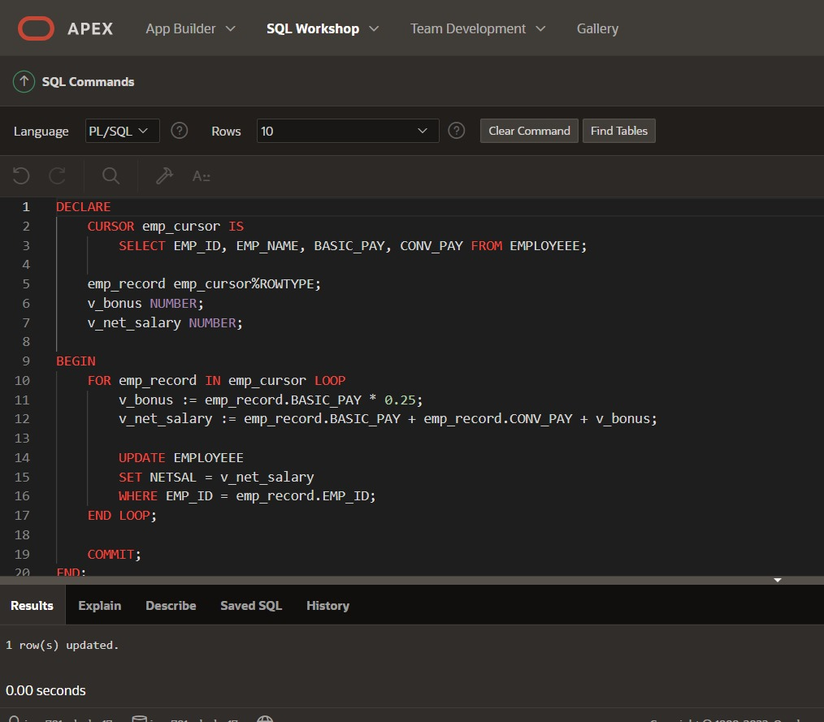

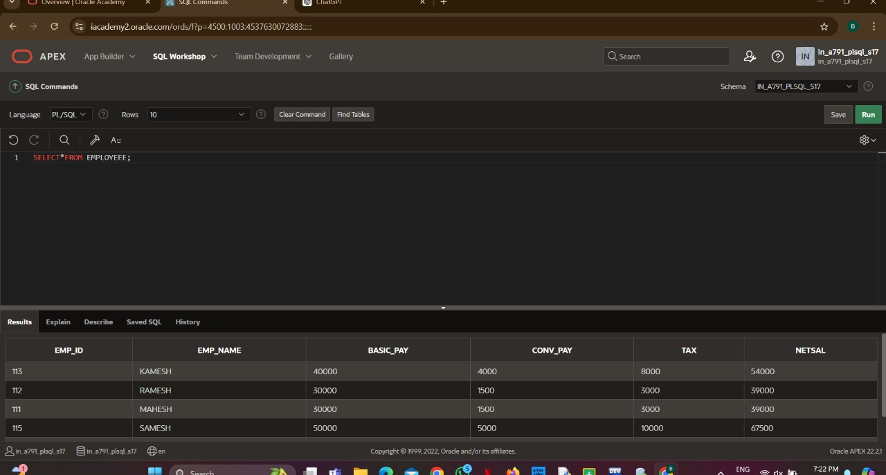

RESULT:

Output has been verified by using explicit cursor.